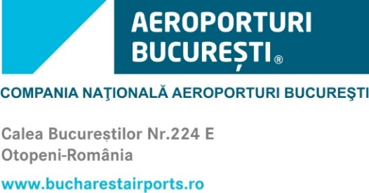
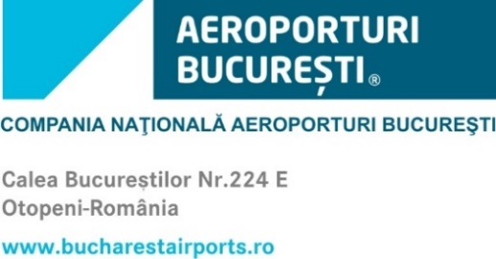

PROTOCOL SERVICES FORM – NATURAL PERSON

TO: BUCHAREST AIRPORTS GENERAL MANAGER,

Please ensure protocol services at the □ VIP Lounge, □ Authorized accompany services for natural persons, on Henri Coandă International Airport:

PASSENGER INFORMATION

Name and Surname | * If the passengers are infants, unaccompanied minors or persons with reduced mobility, please note here.

Special travel information:

□Travel of unaccompanied minors; □Persons with disabilities; □Travel wih pets;
□Transport of weapons and ammunition.

TRAVEL INFORMATION

Flight date (in Bucharest)

Airline
Flight number
Departure to / Arrival from

Flight schedule
departure/ arrival (in Bucharest)

We have been informed and we agree to pay the protocol related fee.
Billing data (for issuing the tax invoice, upon request):
● Name, Surname, National Identification Number, Home Address: City, Street, Number):

Contact Person (Name, Surname, Phone/E-mail)

□ I declare that I undertake full responsibility for the reality and accuracy of the data and information provided in this form.

